inventory.json
A new json file has been created with name ‘inventory.json’ with the given book details as shown below
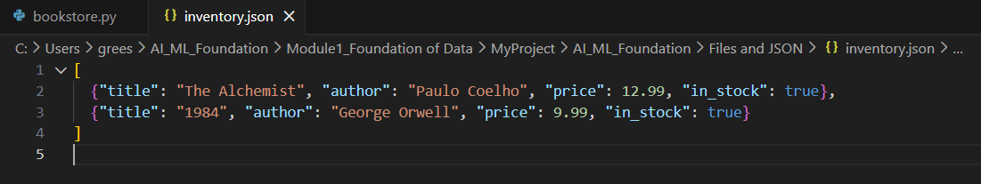

Task 1 — Read the inventory
Steps Followed:
- Opened the inventory.json file with read mode
- Read the total book count using the len()
- Printed the total book count in the console
- Initially, there were only 2 books in the inventory. So, the output is 2
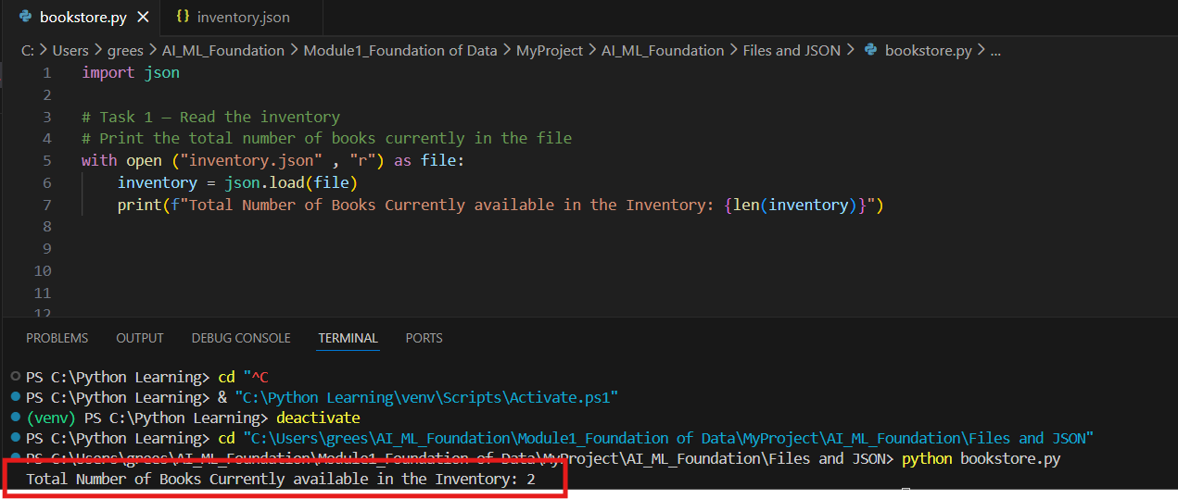

Task 2 — Update and save
Steps Followed:
- Appended the new book details to the inventory object using append()
- Opened the inventory.json file in write mode
- Updated the inventory.json with new inventory object using the json function dump()
The inventory.json before Append the new book details:
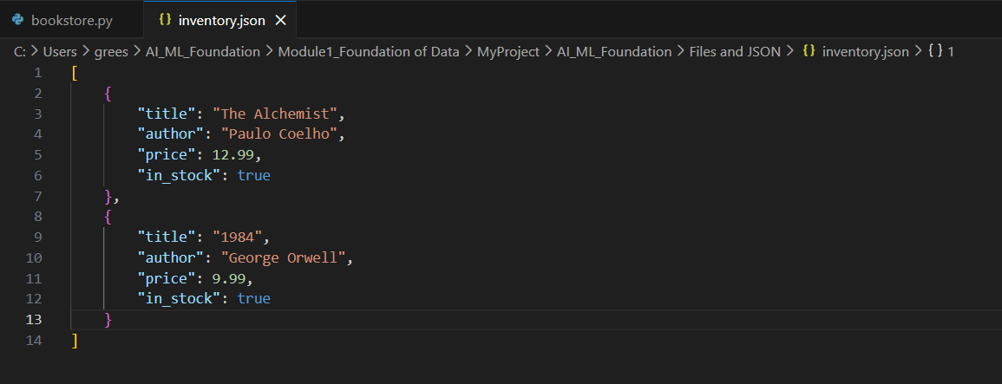
The inventory.json after append the new book details:
The new book detail has appended to the file
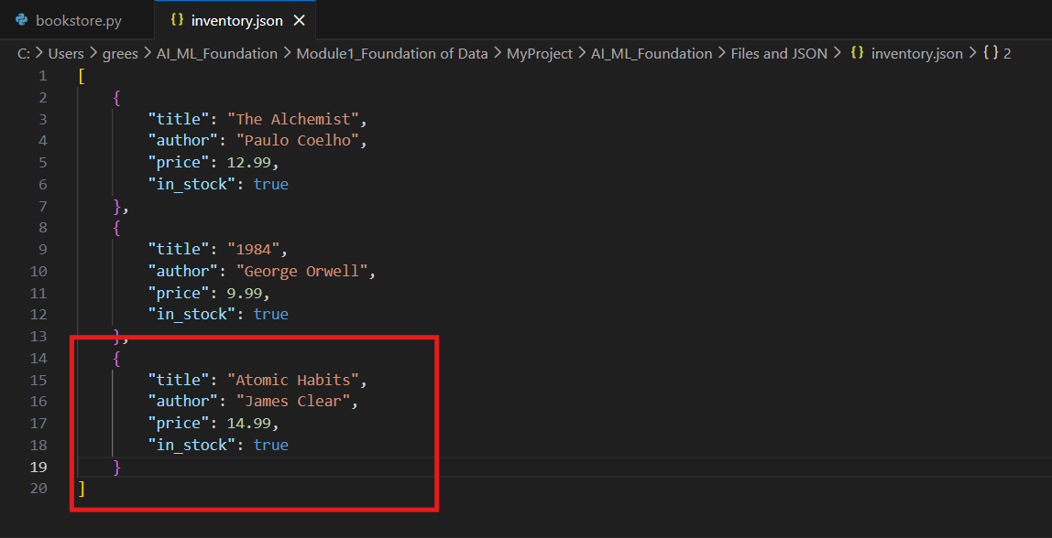

Task 3 — Display the inventory
Steps followed:
- After the new book detail is added to the inventory.json, print the latest file content to the console
